SOFTWARE ENGINEERING DOCUMENTATION
System Design Specification
StudyFlow Academic Management System
Document Version | Version 1.0
Date | November 2026
Prepared By | Gavin Goodman, Danielle Lloyd, Emma Sarkine, & Steven Thomason
Course / Program | System Analysis and Design
Institution | Indiana University
Specification Basis | Source code inspection, branch feature/demo-mode, commit 5f519a4
Related Documents | Project Proposal (Sept 2026); Software Requirements Specification v1.0 (Oct 2026)
This document specifies the design of the implemented StudyFlow build. Every class, table, endpoint and algorithm described here was derived from, and can be traced to, the project source code.

Table of Contents
1.0 – Introduction 4
1.1 – Goals and objectives 4
Overall goals 4
Software objectives 4
1.2 – Statement of scope 5
General requirements 5
Major inputs, processing and outputs 6
Out of scope 6
1.3 – Purpose, audience and references 6
Related documents 6
Document conventions 6
2.0 – Data design 8
2.1 – Data objects 8
2.2 – Class diagram 8
2.3 – Enumerated values 11
3.0 – Architecture design 12
3.1 – Architectural style 12
3.2 – Subsystems 12
3.3 – System architecture diagram 13
3.4 – Component diagram 14
3.5 – Deployment diagram 15
4.0 – Detail design 16
4.1 – Function (method) descriptions 16
4.1.1 Shared helpers 16
4.1.2 Authentication (SS-2) 16
4.1.3 Classes (SS-3) 17
4.1.4 Assignments (SS-3, SS-4) 18
4.1.5 Calendar events (SS-4) 18
4.1.6 Study sessions (SS-5) 19
4.1.7 Dashboard (SS-7) 19
4.1.8 AI services (SS-6) 20
4.1.9 Demo mode (SS-8) 22
4.1.10 Client-side methods (SS-1, SS-5) 23
4.2 – Important algorithms 23
A-1 Assignment and study-session calendar synchronization 23
A-2 Adaptive quiz generation (spaced review) 24
A-3 Context-grounded, streamed chat 24
A-4 Newline-delimited JSON stream parsing 25
A-5 Reload-safe focus timer 25
A-6 Study streak 26
A-7 Date-relative demo seeding 26
5.0 – Database design 27
5.1 – Entity relationship diagram 27
5.2 – Table specifications 28
User 28
Class 28
Assignment 28
CalendarEvent 29
StudySession 29
QuizAttempt 29
ChatConversation 30
ChatMessage 30
5.3 – Relationships and integrity 30
Unique constraints and indexes 31
Migration history 31
6.0 – Software interface design 32
6.1 – User interface 32
Layout and navigation 32
Screens 32
Feedback conventions 33
6.2 – Internal REST API 33
6.3 – External interfaces 35
7.0 – Appendices 36
Appendix A – Technology stack 36
Appendix B – Configuration 36
Appendix C – Requirements traceability 36
Appendix D – Demo data set 37
Appendix E – Known limitations and future work 37
Appendix F – Glossary 37
Appendix G – Revision history 38

1.0 – Introduction
This document describes how StudyFlow is designed: the data it manages, how the system is divided into subsystems, how each operation works, how data is stored, and how users and other systems interact with it. It is written against the implemented source code, so every class, table, endpoint and algorithm described here exists in the current build.

1.1 – Goals and objectives
Students juggle a syllabus per class, a learning management system, a paper planner and a phone calendar. Deadlines get lost between them, and study time is rarely planned against real due dates. StudyFlow replaces that patchwork with one workspace.

Overall goals
- One place for academic work. Classes, assignments, grades, calendar events and study sessions live in a single account.
- Fewer missed deadlines. Every assignment appears on the calendar automatically, and the dashboard surfaces what is due next with color-coded urgency.
- Better study habits. A focus timer, planned study sessions, streak tracking and weekly study-time totals encourage regular, measurable study.
- AI help that knows the student. The assistant answers questions using the student's own classes, deadlines and schedule, and the Study Helper generates practice material for any topic.
- Zero running cost. The default AI model runs locally through Ollama and data is stored in a local SQLite file, so the system runs without paid services.
- Easy evaluation. A one-click demo account loads a realistic semester of sample data.

Software objectives
ID | Objective | How the design meets it
O-1 | Each user sees and changes only their own data. | Every API handler resolves the user from the session and scopes every query by userId (directly or through the owning class).
O-2 | Assignments and study sessions always appear on the calendar. | Creating either record also creates exactly one linked CalendarEvent; updates and deletes keep the pair in step (Algorithm A-1).
O-3 | AI replies feel immediate. | Chat responses stream to the browser chunk by chunk as the model produces them (Algorithm A-3).
O-4 | Quizzes adapt to the student. | Each self-graded answer is recorded; later quizzes avoid mastered questions and revisit missed ones (Algorithm A-2).
O-5 | A running focus timer survives a page reload. | Timer state and its start timestamp are kept in localStorage and recomputed on load (Algorithm A-5).
O-6 | Passwords are never stored in plain text. | Passwords are hashed with bcrypt (cost factor 12) before storage.
O-7 | Usable on phones and desktops. | Desktop sidebar navigation collapses to a fixed bottom icon bar below 1024px.

1.2 – Statement of scope
StudyFlow is a single-user-per-account web application. A student registers with a name, email and password (or enters the demo), then manages their semester through five screens: Dashboard, Calendar, Classes, Study Helper and AI Assistant. All data is private to the account. The system has two kinds of users:
- Registered student: creates an account and owns all data they enter.
- Demo visitor: signs in with one click to a shared demo account that is wiped and reseeded with sample data on every demo sign-in.

General requirements
ID | Requirement
R-1 | Users can register, sign in, sign out, and are redirected to sign-in when they open a protected page without a session.
R-2 | Users can create, view, edit and delete classes (name, color, instructor, room, credits).
R-3 | Users can create, edit, complete, grade and delete assignments within a class, and filter or sort them by type or due date.
R-4 | Users can view a month or week calendar and create, edit and delete events of type class, assignment, study or personal.
R-5 | Users can schedule, edit, complete and delete study sessions, optionally linked to a class, and run a focus timer.
R-6 | Users can generate AI study material in six modes: Practice Problems, Definitions, Flashcards, Study Guide Summary, Key Concepts and Quiz Me.
R-7 | Users can chat with an AI assistant that knows their schedule, and can resume or delete past conversations.
R-8 | The dashboard summarizes classes, open assignments, upcoming sessions, weekly study time and today's schedule.
R-9 | Visitors can open a fully populated demo account without registering.

Major inputs, processing and outputs
Inputs | Processing | Outputs
- Registration and sign-in credentials  - Class details  - Assignment details, completion and grades  - Calendar events  - Study session plans and timer actions  - AI study request: class, mode, topic  - Quiz self-assessment (right / wrong)  - Chat messages | - Authentication and session management  - Input validation and ownership checks  - Create, read, update and delete of all records  - Assignment and study-session calendar synchronization  - Dashboard aggregation and statistics  - Prompt construction and LLM calls  - Quiz mastery tracking  - Streaming and saving chat replies  - Demo account reset and seeding | - Dashboard statistics and today's schedule  - Month and week calendar views  - Class progress percentage and grade lists  - Study insights: streak, weekly minutes  - Generated study material with rendered math  - Interactive quiz cards  - Streamed chat replies and saved history  - Toast notifications and validation errors

Out of scope
Learning-management-system import (Canvas, Blackboard), sharing data between students, email or push reminders, file attachments, and a native mobile app are not part of this release.

1.3 – Purpose, audience and references
The Software Requirements Specification defines what StudyFlow must do. This System Design Specification defines how the implemented build does it. It is intended for the course instructor and reviewers, for team members who maintain or extend the code, and for anyone who needs to trace a requirement to the class, endpoint and table that satisfy it.

Related documents
- StudyFlow Project Proposal, September 2026: project background, objectives, team roles and schedule.
- StudyFlow Software Requirements Specification, Version 1.0, October 2026: functional description, use cases, data description and behavioral rules.
- StudyFlow source repository, branch feature/demo-mode, commit 5f519a4: the code this design was derived from.

Document conventions
- Diagrams follow UML 2 notation (class, component, deployment and sequence diagrams) and crow's-foot notation for the entity relationship diagram.
- Pseudo-code uses upper-case keywords (FUNCTION, IF, RETURN), ← for assignment, and // for comments.
- File paths are relative to src/ unless they start with prisma/.
- Identifiers: R-n (requirement), O-n (objective), SS-n (subsystem), A-n (algorithm).

2.0 – Data design
StudyFlow manages eight persistent data objects, defined once in prisma/schema.prisma and mirrored as TypeScript types. Service classes operate on them.

2.1 – Data objects
Object | Description | Owned by
User | An account holder: name, unique email and bcrypt password hash. | —
Class | A course the student is taking, with a display color used throughout the UI. | User
Assignment | A graded piece of work in a class, with a type, due date, completion flag and free-text grade (for example 94%, A-, 97/100). | Class
CalendarEvent | Anything on the calendar. May be linked to one assignment or one study session; otherwise it is a stand-alone class or personal event. | User
StudySession | A planned or completed block of study time on a topic, optionally tied to a class. | User
QuizAttempt | The running right/wrong record for one quiz question, for one user, class and topic. | User
ChatConversation | A saved AI assistant conversation, titled from its first message. | User
ChatMessage | One user or assistant turn in a conversation. | ChatConversation

2.2 – Class diagram
StudyFlow is written in TypeScript with Next.js route handlers rather than classic object-oriented classes. To present it as a class model, each data object is shown with its attributes and the operations the system performs on it, and each server module is shown as a service class with its functions as methods. Figure 2.1 shows the domain classes; Figure 2.2 shows the service classes and how they depend on the domain. Together they form the complete class model.
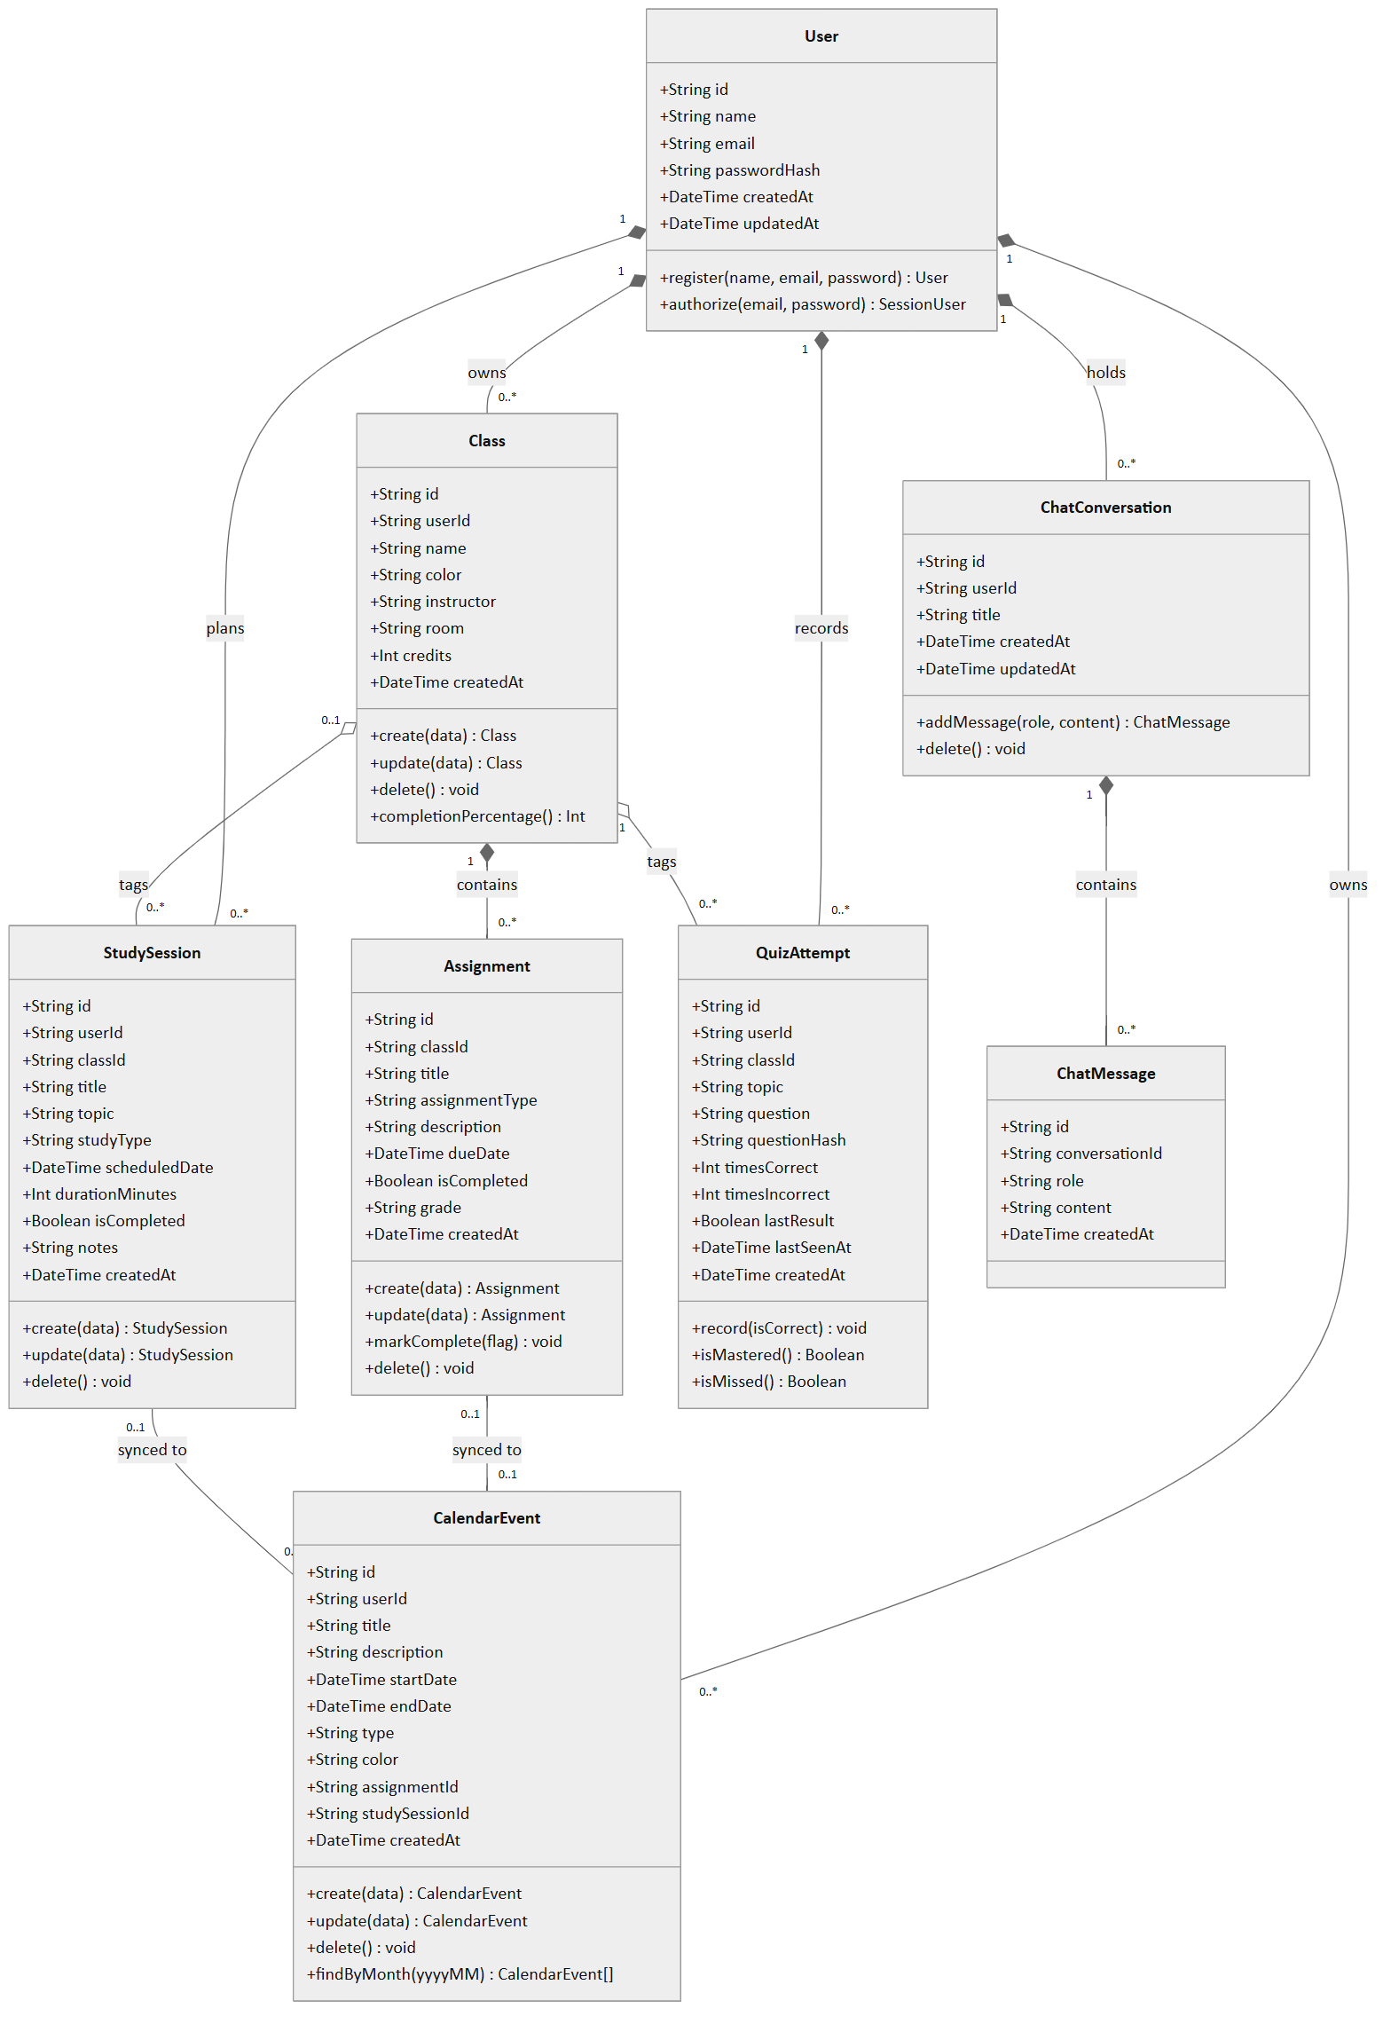
Figure 2.1. Domain class diagram. Filled diamonds mark composition (children are deleted with the parent); hollow diamonds mark aggregation (the link is cleared, the child survives).
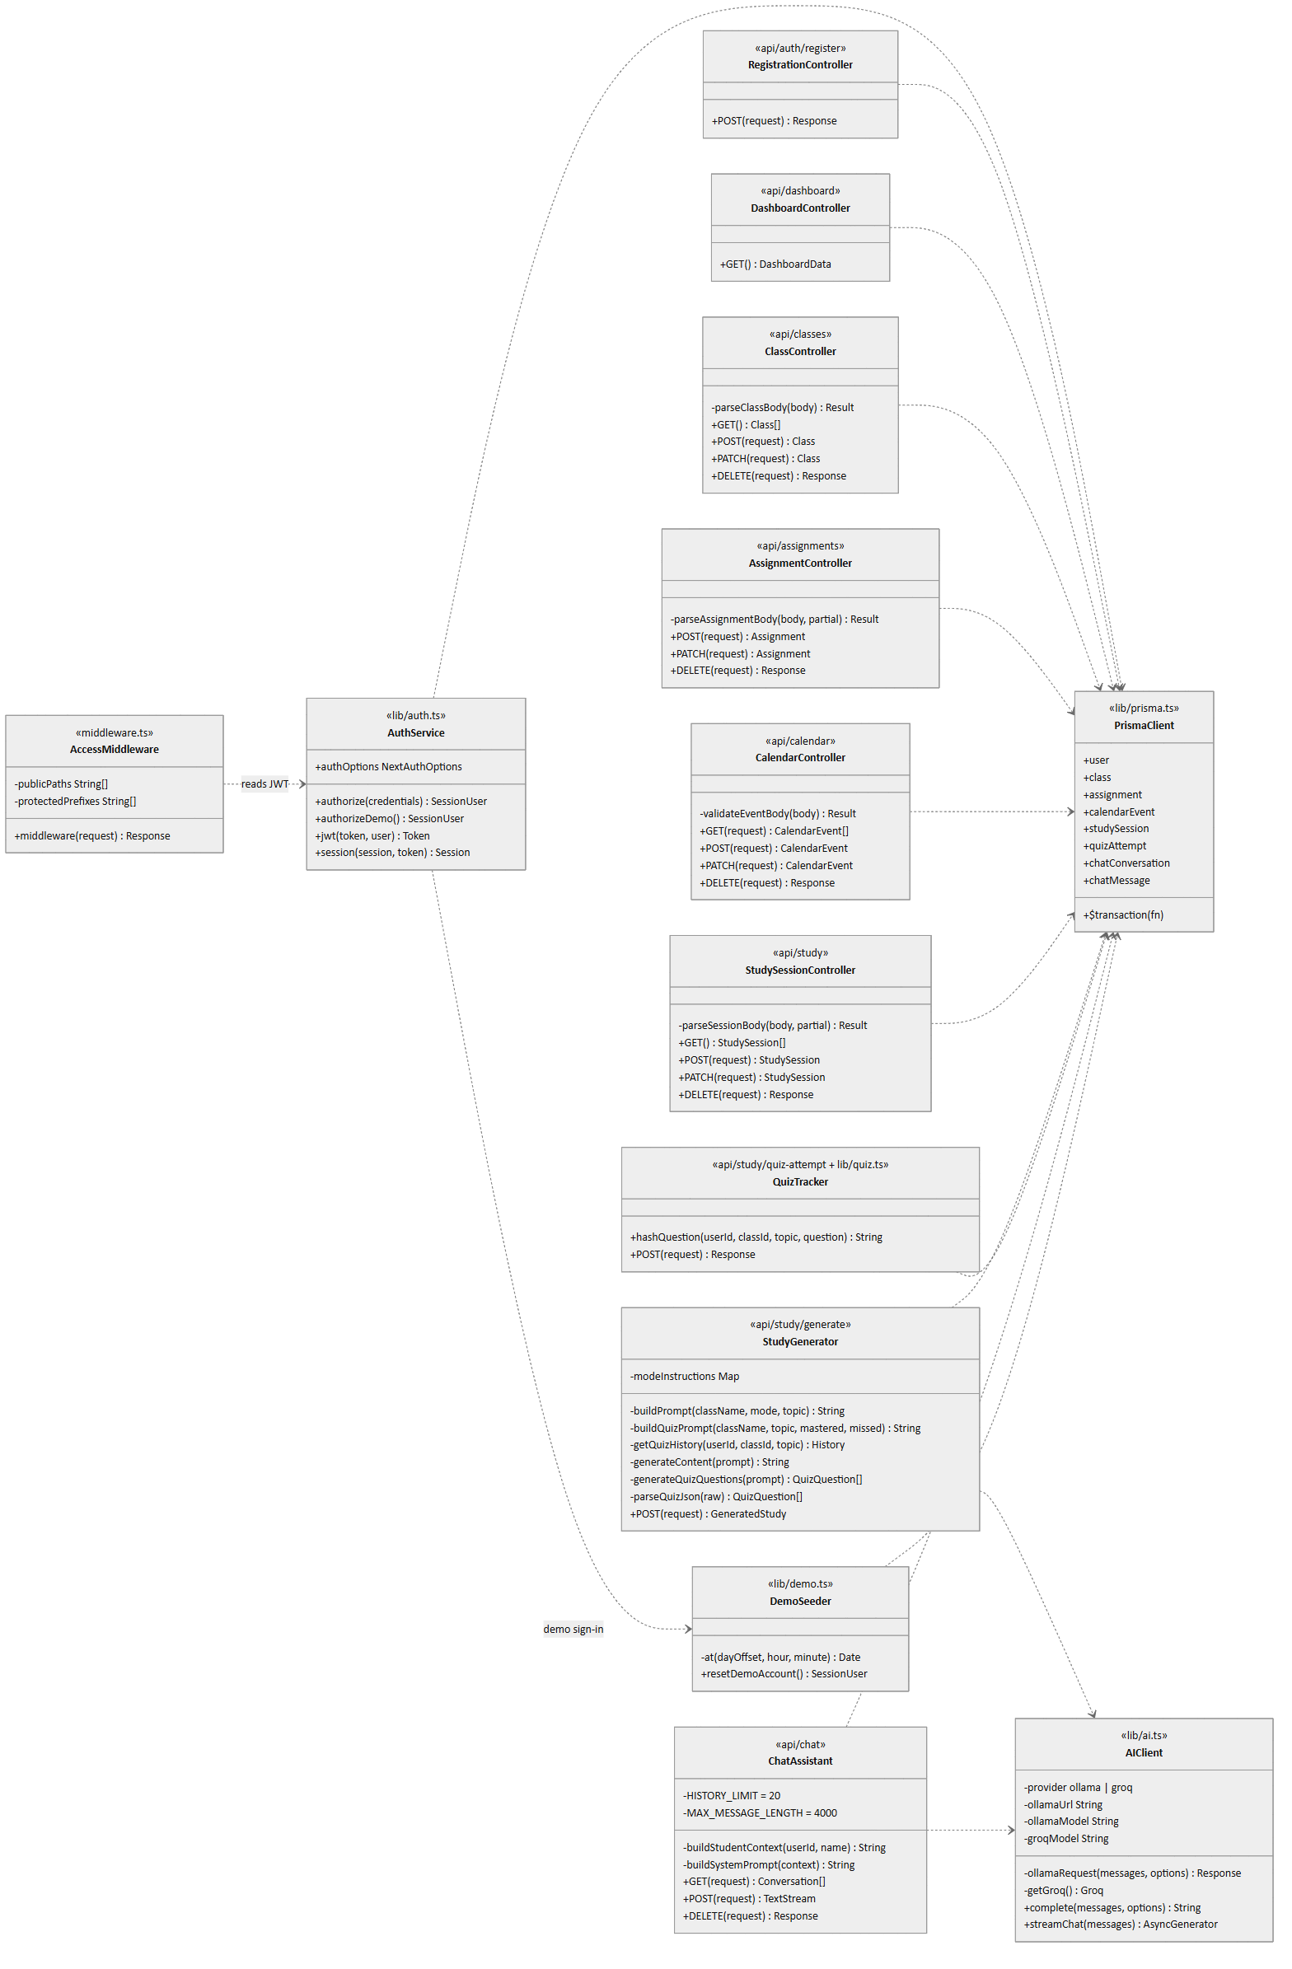
Figure 2.2. Service class diagram. Stereotypes give the source module. Every controller also calls getServerSession(authOptions) to identify the user; those dependencies on AuthService are omitted for readability.

2.3 – Enumerated values
Several text fields accept only a fixed set of values. SQLite has no enum type, so the API layer enforces them.
Field | Allowed values | Enforced in
Assignment.assignmentType | Homework, Quiz, Exam, Midterm, Final, Lab, Project, Discussion Post, Extra Credit, Other | api/assignments
CalendarEvent.type | class, assignment, study, personal | api/calendar
StudySession.studyType | Focus Session (default), Practice Problems, Definitions, Flashcards, Study Guide Summary, Quiz Me, Key Concepts | UI select; API defaults blank to Focus Session
ChatMessage.role | user, assistant | api/chat (the system prompt is built per request and never stored)
Class.color | Hex color string; defaults to #6366f1 | api/classes

3.0 – Architecture design
StudyFlow is a three-tier web application built as a single Next.js project. The browser renders React pages; the same Next.js server hosts the REST API; Prisma persists data to SQLite; an LLM provider is called over HTTP for AI features.

3.1 – Architectural style
- Client–server, three tiers. Presentation (React in the browser), application (Next.js route handlers on Node.js), data (SQLite through Prisma ORM).
- Layered within the server. Route middleware → route handlers (validation, ownership checks, business rules) → shared libraries (auth, ai, quiz, demo) → Prisma data access.
- REST over JSON. Each resource has one route module with handlers for GET, POST, PATCH and DELETE. The chat endpoint streams plain text instead of returning JSON.
- Stateless sessions. NextAuth issues a signed JWT in an HTTP-only cookie, so the server keeps no session table.
- Pluggable AI provider. One module exposes complete() and streamChat(); an environment variable selects local Ollama or hosted Groq without changing callers.

3.2 – Subsystems
ID | Subsystem | Responsibility | Source
SS-1 | Presentation | Pages, layouts, navigation, forms, modals, toasts, loading and empty states. | src/app/(app), src/app/(auth), src/components
SS-2 | Authentication and access control | Registration, credential and demo sign-in, JWT sessions, page protection. | lib/auth.ts, middleware.ts, api/auth/*
SS-3 | Academic management | Classes and assignments, grades, completion, filters, progress. | api/classes, api/assignments
SS-4 | Calendar and scheduling | Event storage, month queries, assignment and study-session synchronization. | api/calendar
SS-5 | Study planning | Study sessions, focus timer, streak and weekly insights. | api/study, (app)/study/page.tsx
SS-6 | AI services | LLM provider access, study-material generation, adaptive quizzes, context-aware chat. | lib/ai.ts, lib/quiz.ts, api/study/generate, api/study/quiz-attempt, api/chat
SS-7 | Dashboard aggregation | Counts, weekly totals, upcoming items and today's schedule in one request. | api/dashboard
SS-8 | Demo mode | Reset and reseed the demo account with date-relative data; show the demo banner. | lib/demo.ts, lib/demo-account.ts, DemoBanner.tsx
SS-9 | Persistence | Schema, migrations, database connection. | prisma/schema.prisma, lib/prisma.ts, dev.db

3.3 – System architecture diagram
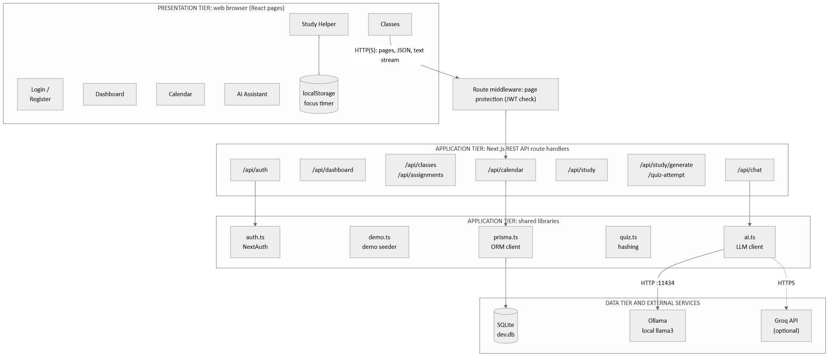
Figure 3.1. System architecture. Solid arrows are the default configuration; the dashed arrow is used only when AI_PROVIDER=groq.

3.4 – Component diagram
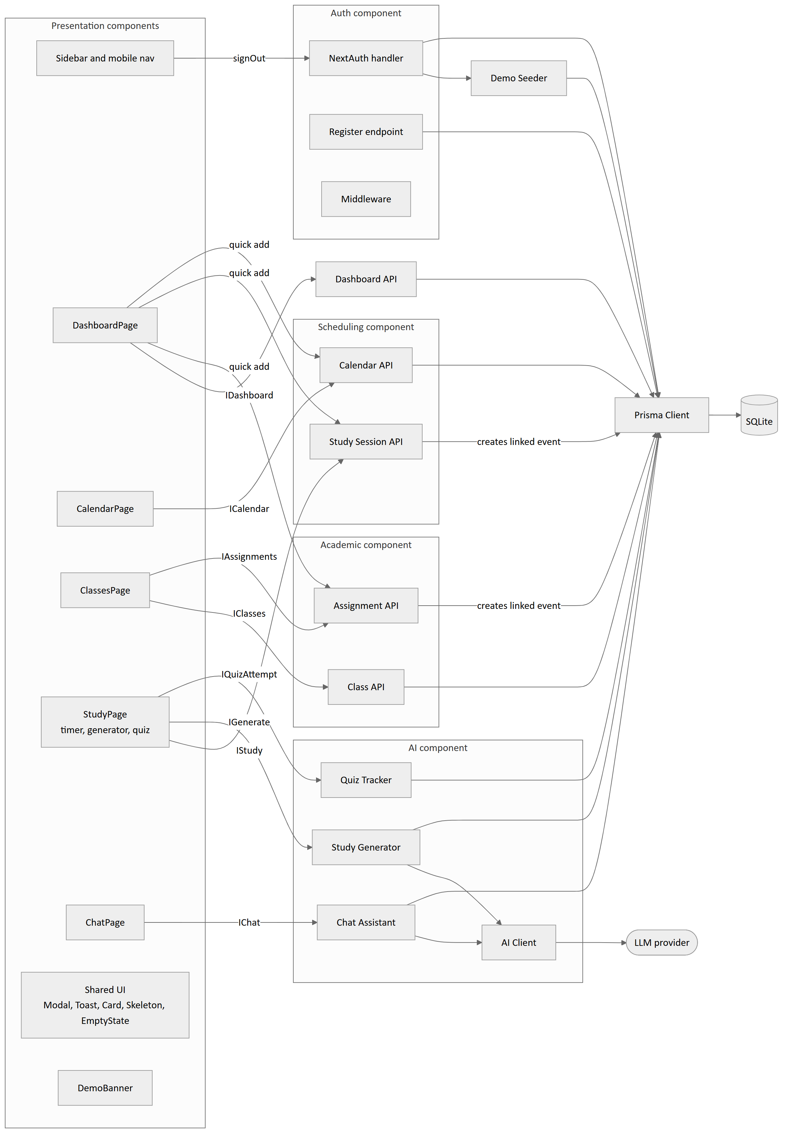
Figure 3.2. Component diagram. Edge labels name the interface each page consumes; Section 6.2 defines each interface.

3.5 – Deployment diagram
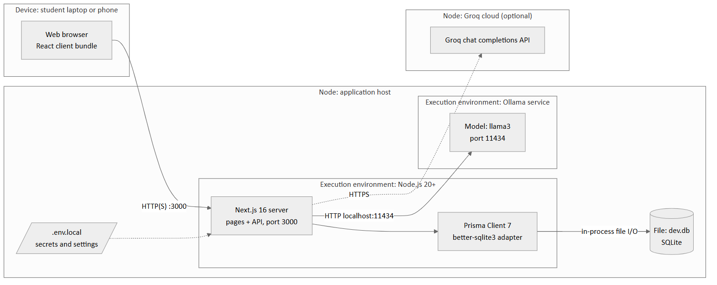
Figure 3.3. Deployment diagram for the reference configuration, where the app server, database file and Ollama run on one machine. SQLite runs in-process, so there is no separate database server.

4.0 – Detail design
Each server method below is given with its source file, inputs, outputs and pseudo-code. All API handlers share two helpers, described first. Section 4.2 then explains the algorithms that carry the most design weight.

4.1 – Function (method) descriptions

4.1.1 Shared helpers
File every api/*/route.ts · In none · Out userId or null
FUNCTION getUserId()
session ← getServerSession(authOptions) // decodes the JWT cookie
RETURN session.user.id IF present ELSE null
END

FUNCTION parseDate(value)
IF value is not a non-blank string THEN RETURN null
date ← new Date(value)
RETURN null IF date is invalid ELSE date
END
Every handler begins with userId ← getUserId() and returns 401 Unauthorized when it is null. This step is omitted from the pseudo-code that follows.

4.1.2 Authentication (SS-2)
register · POST /api/auth/register
In { name, email, password } · Out 201 { success } | 400 | 409 | 500
FUNCTION register(body)
IF name, email or password missing THEN RETURN 400 "Name, email, and password are required."
email ← lowercase(trim(email))
IF email = DEMO_EMAIL THEN RETURN 409 "This email is reserved for the demo account."
IF User exists with email THEN RETURN 409 "An account with this email already exists."
hash ← bcrypt.hash(password, cost = 12)
CREATE User { name: trim(name), email, passwordHash: hash }
RETURN 201 { success: true }
END
authorize · credentials provider in lib/auth.ts
In { email, password } · Out SessionUser or null
FUNCTION authorize(credentials)
email ← lowercase(trim(credentials.email))
IF email or password empty THEN RETURN null
user ← FIND User WHERE email
IF user is null THEN RETURN null
IF NOT bcrypt.compare(password, user.passwordHash) THEN RETURN null
RETURN { id, email, name: user.name OR email }
END

FUNCTION authorizeDemo() // provider id "demo", no credentials
RETURN resetDemoAccount() // see 4.1.9
END

FUNCTION jwt(token, user)
IF user present (first sign-in) THEN token.id ← user.id; token.name ← user.name OR user.email
RETURN token
END

FUNCTION session(session, token)
session.user.id ← token.id; session.user.name ← token.name
RETURN session
END
middleware · src/middleware.ts
In request · Out continue | redirect to /login
FUNCTION middleware(request)
path ← request.pathname
IF path is under /login, /register or /api/auth THEN RETURN continue
IF path is not under /dashboard, /calendar, /classes, /study or /chat THEN RETURN continue
token ← getToken(request, NEXTAUTH_SECRET)
IF token is null THEN RETURN redirect("/login?callbackUrl=" + path)
RETURN continue
END

4.1.3 Classes (SS-3)
File api/classes/route.ts
FUNCTION parseClassBody(body)
name ← trim(body.name); color ← body.color OR "#6366f1"
instructor, room ← trimmed value OR null
credits ← null IF blank ELSE Number(body.credits)
IF name empty THEN RETURN error "Class name is required."
IF credits not null AND (not an integer OR credits < 0) THEN RETURN error "Credits must be a non-negative whole number."
RETURN data { name, color, instructor, room, credits }
END

GET → RETURN Classes WHERE userId, INCLUDE assignments ORDER BY dueDate, ORDER BY name
POST → result ← parseClassBody(body); IF error THEN 400
RETURN 201 CREATE Class { ...data, userId }
PATCH ?id → IF no Class WHERE id AND userId THEN 404
result ← parseClassBody(body); IF error THEN 400
RETURN UPDATE Class id SET data
DELETE ?id → n ← DELETE Classes WHERE id AND userId
IF n = 0 THEN 404 ELSE { success: true }
// database cascades delete the class's assignments and their linked events;
// study sessions and quiz attempts keep their rows with classId set to null

4.1.4 Assignments (SS-3, SS-4)
File api/assignments/route.ts
FUNCTION parseAssignmentBody(body, partial = false)
title ← trim(body.title); type ← body.assignmentType; due ← parseDate(body.dueDate)
IF NOT partial:
require title, due, and type ∈ ASSIGNMENT_TYPES
IF partial:
validate only the fields that are present
data ← only the fields present in body (description and grade trimmed, blank → null;
isCompleted coerced to Boolean)
RETURN data
END

FUNCTION createAssignment(body) // POST
data ← parseAssignmentBody(body); IF error THEN 400
cls ← FIND Class WHERE id = data.classId AND userId; IF none THEN 404
a ← CREATE Assignment data
CREATE CalendarEvent { userId, title: a.title, description: a.description,
startDate: a.dueDate, endDate: a.dueDate + 1 hour,
type: "assignment", color: cls.color, assignmentId: a.id }
RETURN 201 a
END

FUNCTION updateAssignment(id, body) // PATCH ?id
existing ← FIND Assignment id WHERE class.userId = userId; IF none THEN 404
data ← parseAssignmentBody(body, partial = true); IF error THEN 400
remove data.classId // assignments cannot move between classes
updated ← UPDATE Assignment id SET data
IF existing.calendarEvent THEN syncAssignmentEvent(existing, data) // Algorithm A-1
RETURN updated
END

FUNCTION deleteAssignment(id) // DELETE ?id
a ← FIND Assignment id WHERE class.userId = userId; IF none THEN 404
IF a.calendarEvent THEN DELETE CalendarEvent a.calendarEvent.id
DELETE Assignment id
RETURN { success: true }
END

4.1.5 Calendar events (SS-4)
File api/calendar/route.ts
FUNCTION validateEventBody(body)
require non-empty title, valid startDate and endDate, endDate after startDate,
type ∈ { class, assignment, study, personal }
color ← body.color OR "#6366f1"; description ← trimmed OR null
RETURN data
END

FUNCTION getEvents(month?) // GET ?month=YYYY-MM
filter ← { userId }
IF month given:
IF month does not match /^\d{4}-\d{2}$/ THEN 400 "month must use YYYY-MM format."
start ← first day of month; end ← first day of next month
IF month number invalid THEN 400 "Invalid month."
filter.startDate ← { ≥ start, before end }
RETURN CalendarEvents WHERE filter ORDER BY startDate
END

POST → data ← validateEventBody(body); RETURN 201 CREATE CalendarEvent { ...data, userId }
PATCH ?id → IF no event WHERE id AND userId THEN 404; RETURN UPDATE with validateEventBody(body)
DELETE ?id → n ← DELETE events WHERE id AND userId; IF n = 0 THEN 404

4.1.6 Study sessions (SS-5)
File api/study/route.ts
FUNCTION parseSessionBody(body, partial = false)
IF NOT partial: require title, topic, valid scheduledDate, durationMinutes ≥ 1
IF durationMinutes present: require integer in 1..1440
studyType ← trimmed value OR "Focus Session"
classId ← value OR null
RETURN only the fields present in body
END

FUNCTION createSession(body) // POST
data ← parseSessionBody(body); IF error THEN 400
cls ← data.classId ? FIND Class WHERE id AND userId : null
IF data.classId AND cls is null THEN 404
s ← CREATE StudySession { ...data, userId }
CREATE CalendarEvent { userId, title: s.title, description: s.topic,
startDate: s.scheduledDate, endDate: s.scheduledDate + s.durationMinutes,
type: "study", color: cls.color OR "#8b5cf6", studySessionId: s.id }
RETURN 201 s
END

FUNCTION updateSession(id, body) // PATCH ?id
existing ← FIND StudySession id AND userId; IF none THEN 404
data ← parseSessionBody(body, partial = true)
IF data.classId AND not owned by user THEN 404
s ← UPDATE StudySession id SET data
IF existing.calendarEvent:
start ← data.scheduledDate OR existing.scheduledDate
mins ← data.durationMinutes OR existing.durationMinutes
UPDATE that event SET title, description ← topic, startDate ← start, endDate ← start + mins
RETURN s
END

GET → RETURN StudySessions WHERE userId INCLUDE class(id, name, color) ORDER BY scheduledDate
DELETE ?id → delete linked CalendarEvent if any, then the StudySession; 404 if not owned

4.1.7 Dashboard (SS-7)
File api/dashboard/route.ts · Out { stats, upcomingAssignments, upcomingEvents, todaysSchedule, todaysStudySessions }
FUNCTION getDashboard()
now ← current time; today ← [00:00, 23:59:59.999]; week ← [startOfWeek(now), endOfWeek(now)]
RUN IN PARALLEL:
classCount ← COUNT Classes WHERE userId
openAssignments ← COUNT Assignments WHERE class.userId AND NOT isCompleted
sessionsNext7 ← COUNT StudySessions WHERE NOT isCompleted AND scheduledDate ∈ [now, now + 7 days]
doneThisWeek ← StudySessions WHERE isCompleted AND scheduledDate ∈ week
nextEvents ← first 3 CalendarEvents with startDate ≥ now
nextAssignments ← first 3 open Assignments with dueDate ≥ now, INCLUDE class
todaysEvents ← CalendarEvents with startDate ∈ today
todaysSessions ← StudySessions with scheduledDate ∈ today
nextDeadline ← first CalendarEvent of type "assignment" with startDate ≥ now
daysUntil ← nextDeadline ? max(0, ceil((nextDeadline.startDate − now) / 1 day)) : 0
RETURN stats { classCount, openAssignments, sessionsNext7,
completedStudyMinutesThisWeek: SUM(doneThisWeek.durationMinutes), daysUntil }
plus the lists, each mapped to display fields (title, dates, class name, color)
END

4.1.8 AI services (SS-6)
AI client · lib/ai.ts
provider ← "groq" IF env.AI_PROVIDER = "groq" ELSE "ollama"

FUNCTION complete(messages, { json }) // full reply as one string
IF provider = groq:
r ← Groq.chat.completions.create(model, messages, json ? response_format json_object)
RETURN r.choices[0].message.content OR ""
r ← ollamaRequest(messages, stream = false, json)
RETURN r.message.content OR ""
END

FUNCTION streamChat(messages) // async generator of text chunks
IF provider = groq:
FOR EACH chunk IN Groq stream: YIELD chunk.delta.content if present
RETURN
response ← ollamaRequest(messages, stream = true)
parse response body as newline-delimited JSON // Algorithm A-4
END

FUNCTION ollamaRequest(messages, { stream, json })
TRY POST {OLLAMA_URL}/api/chat { model, messages, stream, format: json?, options: { num_ctx: 8192 } }
CATCH network error → THROW "Could not reach Ollama at {url}. Is the Ollama app running?"
IF status not OK THEN THROW "Ollama request failed ({status})"
RETURN response
END
generateStudy · POST /api/study/generate
In { className, studyType, topic, classId? } · Out { content } or { questions[] }
FUNCTION generateStudy(body)
IF className missing OR studyType ∉ MODES THEN 400
IF topic missing THEN 400
IF studyType = "Quiz Me":
{ mastered, missed } ← getQuizHistory(userId, classId, topic) // Algorithm A-2
prompt ← buildQuizPrompt(className, topic, mastered, missed)
RETURN { questions: generateQuizQuestions(prompt), ... }
prompt ← buildPrompt(className, studyType, topic)
RETURN { content: generateContent(prompt), ... }
END

FUNCTION buildPrompt(className, mode, topic)
RETURN tutor role for className + topic restriction
+ modeInstructions[mode] // exact markdown pattern per mode
+ formatting rules ($…$ math, ### headings, <details> blocks)
+ random seed so repeated requests vary
END

FUNCTION generateContent(prompt)
TRY text ← complete([user: prompt]); RETURN normalizeMathDelimiters(trim(text)) OR FRIENDLY_ERROR
CATCH RETURN FRIENDLY_ERROR
END

FUNCTION generateQuizQuestions(prompt)
TRY raw ← complete([user: prompt], json = true)
list ← parseQuizJson(raw); IF null THEN RETURN [FRIENDLY_ERROR question]
RETURN list mapped to { question, answer, explanation } with math normalized
CATCH RETURN [FRIENDLY_ERROR question]
END

FUNCTION parseQuizJson(raw)
cleaned ← raw without leading ```json / trailing ``` fences
data ← JSON.parse(cleaned) OR RETURN null
IF data is an array THEN RETURN data
IF data.questions is an array THEN RETURN data.questions
RETURN null
END

FUNCTION normalizeMathDelimiters(text) // lib/utils.ts
replace "\[" and "\]" with "$$"; replace "\(" and "\)" with "$"
END
recordQuizAttempt · POST /api/study/quiz-attempt
In { classId?, topic, question, isCorrect } · Out { success }
FUNCTION recordQuizAttempt(body)
IF topic or question empty OR isCorrect not Boolean THEN 400
hash ← hashQuestion(userId, classId, topic, question)
row ← FIND QuizAttempt WHERE userId, classId, topic, questionHash = hash
IF row exists:
UPDATE row SET timesCorrect += isCorrect ? 1 : 0, timesIncorrect += isCorrect ? 0 : 1,
lastResult ← isCorrect, lastSeenAt ← now
ELSE
CREATE QuizAttempt { userId, classId, topic, question, hash,
timesCorrect: isCorrect ? 1 : 0, timesIncorrect: isCorrect ? 0 : 1, lastResult: isCorrect }
RETURN { success: true }
END
Chat assistant · api/chat/route.ts
GET ?id → RETURN conversation id (owned by user) with messages ORDER BY createdAt, or 404
GET → RETURN [{ id, title, updatedAt }] of user's conversations ORDER BY updatedAt desc
DELETE ?id → delete conversation (messages cascade), 404 if not owned

FUNCTION sendMessage(body) // POST, Algorithm A-3
message ← trim(body.message)
IF empty THEN 400; IF length > 4000 THEN 400
IF body.conversationId: verify owned by user, else 404
ELSE create conversation titled with message (cut to 57 chars + "..." if over 60)
SAVE ChatMessage { role: user, content: message }
history ← last 20 messages of conversation, oldest first
prompt ← [system: buildSystemPrompt(buildStudentContext(userId, name))] + history
RETURN streaming response (text/plain, header X-Conversation-Id) that:
FOR EACH chunk IN streamChat(prompt): append to reply; send chunk
ON ERROR: append and send an apology notice
SAVE ChatMessage { role: assistant, content: reply OR "_No response._" }
touch conversation.updatedAt; close stream
END

FUNCTION buildStudentContext(userId, name)
RUN IN PARALLEL:
classes ← all user classes by name
assignments ← due from now − 14 days to now + 30 days, with class name
sessions ← scheduled from now − 7 days to now + 14 days, with class name
events ← personal and class events from now to now + 14 days
RETURN text block: current date/time, student name, then one line per item under
CLASSES, ASSIGNMENTS (status: completed + grade | OVERDUE | not completed),
STUDY SESSIONS, OTHER CALENDAR EVENTS ("None." when a list is empty)
END

4.1.9 Demo mode (SS-8)
File lib/demo.ts · Out SessionUser for demo@studyflow.app
FUNCTION at(dayOffset, hour, minute = 0)
RETURN startOfDay(today + dayOffset days) at hour:minute
END

FUNCTION resetDemoAccount()
user ← UPSERT User demo@studyflow.app (new accounts get a bcrypt hash of a random UUID,
so the account cannot be signed into with a password)
IN ONE TRANSACTION:
DELETE user's ChatConversations, CalendarEvents, QuizAttempts, StudySessions, Classes
CREATE 4 Classes; remember id and color per class key
FOR EACH of 16 assignments: CREATE Assignment at(dayOffset, …) + linked "assignment" event
FOR EACH of 8 sessions: CREATE StudySession + linked "study" event
CREATE 4 personal events
CREATE 1 ChatConversation with 2 messages
RETURN { id, email, name }
END

4.1.10 Client-side methods (SS-1, SS-5)
FUNCTION completionPercentage(class) // classes/page.tsx
total ← count(class.assignments); done ← count where isCompleted
RETURN total = 0 ? 0 : round(done / total × 100)
END

FUNCTION filterAndSort(assignments, typeFilter, sortKey)
list ← typeFilter = "All" ? assignments : those with assignmentType = typeFilter
IF sortKey = "dueDate" THEN sort by dueDate
ELSE sort by assignmentType, then by dueDate
END

FUNCTION dueDateTone(dueDate) // dashboard/page.tsx
days ← ceil((dueDate − now) / 1 day)
IF days ≤ 2 THEN RETURN red; IF days ≤ 5 THEN RETURN orange; ELSE RETURN neutral
END

FUNCTION sendChat(text) // chat/page.tsx
response ← POST /api/chat { conversationId, message: text }
IF new conversation THEN activeId ← response header X-Conversation-Id
reader ← response.body.getReader()
WHILE chunk ← reader.read(): append decoded chunk to the assistant bubble
refresh conversation list
END
The focus timer and study streak are described as Algorithms A-5 and A-6.

4.2 – Important algorithms

A-1 Assignment and study-session calendar synchronization
Assignments and study sessions are separate records from calendar events, but students expect both on the calendar. Each one owns at most one CalendarEvent, linked by the unique foreign keys assignmentId and studySessionId.
- On create, the handler inserts the record, then inserts its event. Assignment events span one hour from the due date and take the class color. Study events span durationMinutes from the scheduled time and take the class color, or violet #8b5cf6 when no class is chosen.
- On update, the handler recomputes the event from the merged old and new values, so a partial update (for example only isCompleted) still produces a consistent event.
- Completion marker. For assignments, the event title gets a trailing ✓ when the assignment is complete. The handler first strips any existing marker with the pattern /\s+✓$/, so toggling completion repeatedly never stacks marks.
- On delete, the handler deletes the event, then the record. The ON DELETE CASCADE rule on both link columns also removes the event when a parent is deleted indirectly, such as deleting a class.
FUNCTION syncAssignmentEvent(existing, changes)
base ← (changes.title OR existing.title) with trailing " ✓" removed
done ← changes.isCompleted IF provided ELSE existing.isCompleted
due ← changes.dueDate OR existing.dueDate
UPDATE CalendarEvent existing.calendarEvent.id SET
title ← done ? base + " ✓" : base,
description ← changes.description OR existing.description,
startDate ← due, endDate ← due + 1 hour, color ← existing.class.color
END
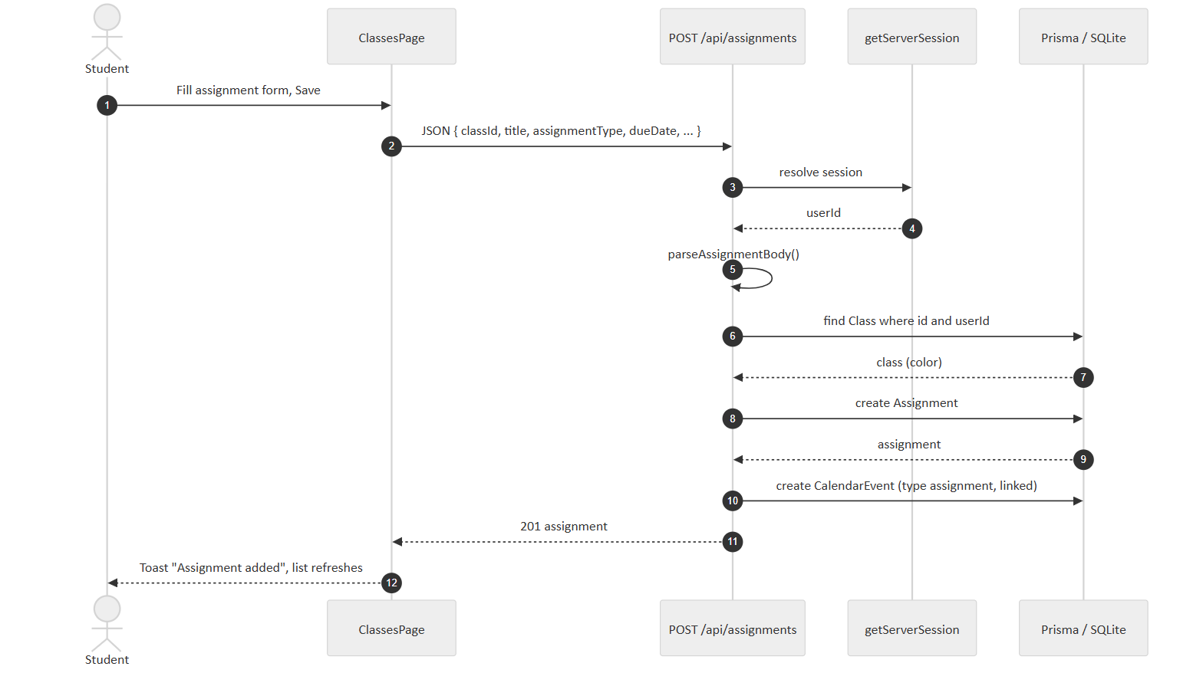
Figure 4.1. Sequence for creating an assignment and its linked calendar event.

A-2 Adaptive quiz generation (spaced review)
Quiz Me should not keep asking what the student already knows, and should return to what they got wrong. The model generates new questions each time, so questions are matched across sessions by a normalized hash.
- Normalize and hash. hashQuestion builds userId|classId|lowercase(trim(topic))|lowercase(question with whitespace runs collapsed) and returns its SHA-256 hex digest. Minor spacing or casing differences map to the same row.
- Record. Each “I got it right / wrong” click updates or inserts the matching QuizAttempt, incrementing the right counter and storing lastResult. A findFirst lookup is used instead of the compound unique key because SQLite unique keys cannot be queried with a null classId.
- Select history. Load the 40 most recently seen attempts for the user, class and topic. Mastered = last answer correct and at least one correct (up to 8). Missed = last answer wrong, or more wrong than right (up to 8).
- Prompt. The quiz prompt lists mastered questions as “mostly avoid” and missed questions as “prioritize asking again or a similar question”, then asks for exactly 5 questions as JSON { questions: [{ question, answer, explanation }] }.
- Parse defensively. Strip code fences, accept either a bare array or the questions key, and fall back to a single friendly error card on any failure.
Cost: one indexed lookup and one write per answer; one bounded read (40 rows) per quiz.

A-3 Context-grounded, streamed chat
The assistant answers questions like “what's due this week?” without tool calls, by placing a summary of the student's data in the system prompt on every turn.
- Save the user's message first, so it is never lost even if generation fails.
- Build the context from four parallel queries with fixed windows: assignments from 14 days ago to 30 days ahead, study sessions from 7 days ago to 14 days ahead, and personal or class events for the next 14 days. Each item is one line with its status, so overdue work is labelled OVERDUE.
- Send the system prompt plus the latest 20 messages. The window and the 4,000-character message cap keep the prompt inside a small local model's 8,192-token context.
- Stream: each chunk from streamChat is sent to the browser immediately and appended to a buffer.
- When the stream ends, or fails part-way, save the buffered reply (with an apology appended on failure) and update the conversation's updatedAt so it sorts to the top.
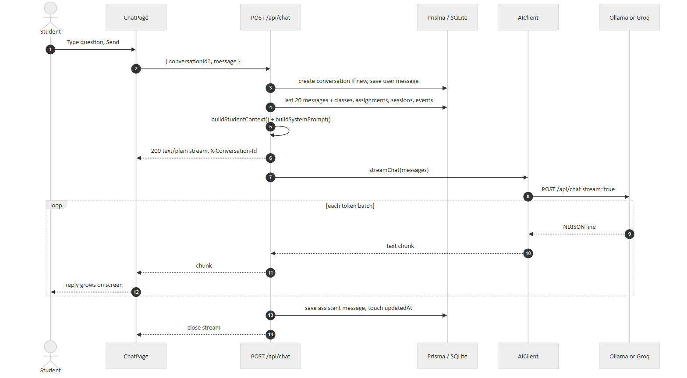
Figure 4.2. Sequence for a streamed assistant reply.

A-4 Newline-delimited JSON stream parsing
Ollama streams one JSON object per line, but network chunks do not align with line boundaries. The parser keeps the incomplete tail between reads.
buffer ← ""
WHILE (done, bytes) ← reader.read() and not done:
buffer ← buffer + utf8Decode(bytes, stream = true) // handles split multi-byte characters
lines ← split(buffer, "\n")
buffer ← last element of lines // possibly incomplete; keep for next read
FOR EACH line IN lines except last:
IF line is blank THEN CONTINUE
obj ← JSON.parse(line)
IF obj.error THEN THROW obj.error
IF obj.message.content THEN YIELD obj.message.content

A-5 Reload-safe focus timer
Ticking a counter once per second is lost on reload and drifts when the browser throttles background tabs. The timer stores the moment it started and recomputes elapsed time from the clock.
ON PAGE LOAD:
saved ← JSON.parse(localStorage["studyflow-focus-timer"]) OR skip (discard if corrupt)
elapsed ← saved.isRunning ? floor((now − saved.startTimestamp) / 1000) : 0
remaining ← max(0, saved.secondsRemaining − elapsed)
timer ← { ...saved, secondsRemaining: remaining, isRunning: saved.isRunning AND remaining > 0 }
hydrated ← true // prevents overwriting storage before load

ON ANY TIMER CHANGE (after hydrated): write timer + chosen duration to localStorage
EVERY SECOND WHILE running:
IF secondsRemaining ≤ 1 THEN stop; schedule finishTimer() on next macrotask
ELSE secondsRemaining ← secondsRemaining − 1

FUNCTION finishTimer()
play 880 Hz sine tone, 0.35 s exponential fade (Web Audio API)
show toast "Session Complete!"
IF the timer was started while AI study content was open for a class:
POST /api/study { title: "{mode} session", studyType: mode, classId,
scheduledDate: aiSessionStartedAt, durationMinutes, isCompleted: true }
The ring turns green during the final five minutes of a running session.

A-6 Study streak
The streak is the number of consecutive days, ending today, with at least one completed study session. If nothing is completed yet today, counting starts from yesterday so an unbroken streak is not shown as zero in the morning.
days ← set of "yyyy-MM-dd" for every completed session's scheduledDate
cursor ← startOfDay(today)
IF cursor ∉ days THEN cursor ← cursor − 1 day
count ← 0
WHILE cursor ∈ days: count ← count + 1; cursor ← cursor − 1 day
RETURN count // O(n) to build the set, O(streak) to count

A-7 Date-relative demo seeding
Fixed demo dates would go stale within weeks. Every seeded date is written as at(dayOffset, hour, minute) relative to today, so any visit shows the same mix of completed, overdue, due-today and upcoming work. The whole wipe and reseed runs inside one database transaction, so a visitor never sees a half-built account, and the reset on every demo sign-in means one visitor's edits never reach the next.

5.0 – Database design
The database is SQLite, accessed through Prisma ORM 7 with the better-sqlite3 driver adapter. The schema is defined in prisma/schema.prisma and applied through versioned migrations. All primary keys are UUID v4 strings generated by Prisma.

5.1 – Entity relationship diagram
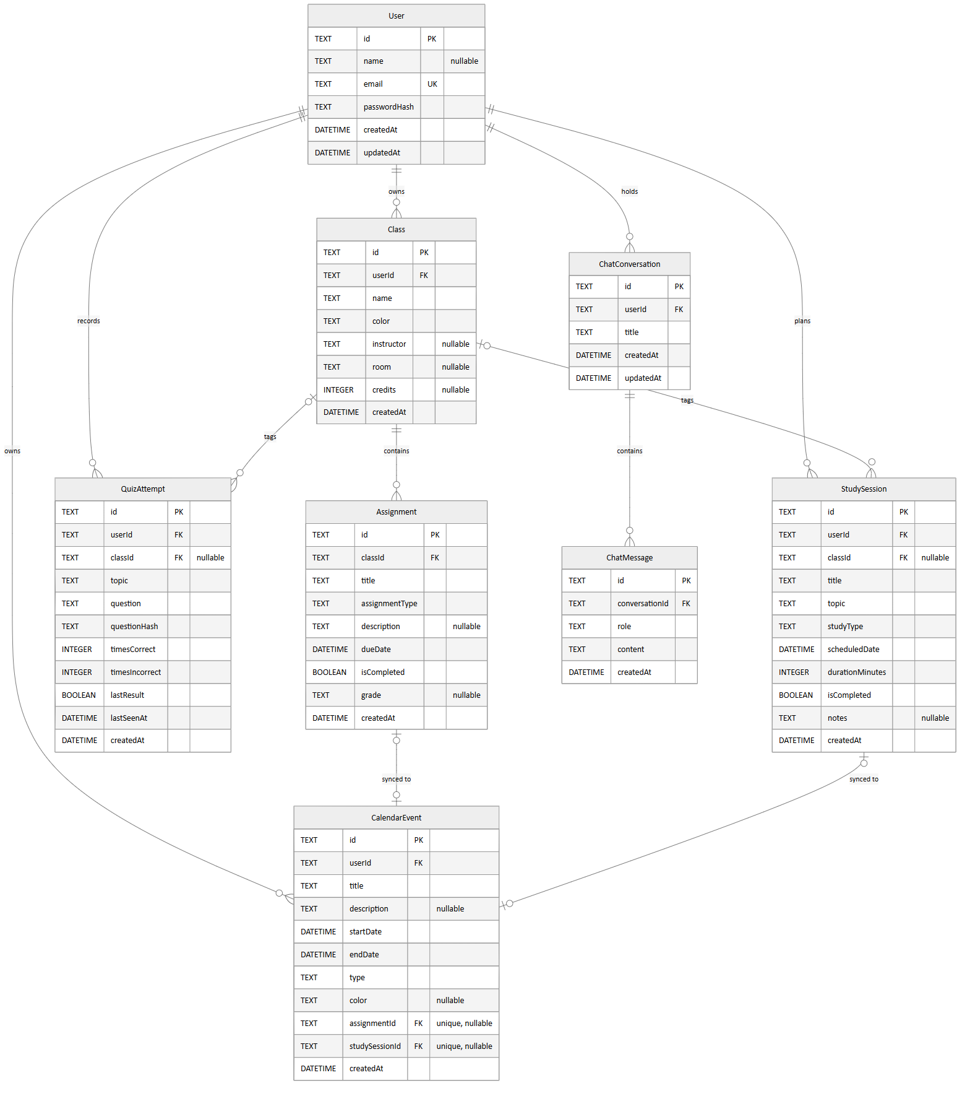
Figure 5.1. Entity relationship diagram in crow's-foot notation, with SQLite column types, primary keys (PK), foreign keys (FK) and unique keys (UK).

5.2 – Table specifications
Types are the SQLite storage types generated by the migrations. “Req.” means NOT NULL.

User
Field | Type | Req. | Key / default | Description
id | TEXT | Yes | PK uuid() | User identifier
name | TEXT | No |  | Display name
email | TEXT | Yes | UNIQUE | Lower-cased sign-in email
passwordHash | TEXT | Yes |  | bcrypt hash
createdAt | DATETIME | Yes | now() | Created
updatedAt | DATETIME | Yes | auto-updated | Last modified

Class
Field | Type | Req. | Key / default | Description
id | TEXT | Yes | PK uuid() | Class identifier
userId | TEXT | Yes | FK → User.id | Owner
name | TEXT | Yes |  | Course name, e.g. Calculus II
color | TEXT | Yes | API default #6366f1 | Hex color for UI and events
instructor | TEXT | No |  | Instructor name
room | TEXT | No |  | Meeting location
credits | INTEGER | No |  | Credit hours, non-negative
createdAt | DATETIME | Yes | now() | Created

Assignment
Field | Type | Req. | Key / default | Description
id | TEXT | Yes | PK uuid() | Assignment identifier
classId | TEXT | Yes | FK → Class.id | Owning class
title | TEXT | Yes |  | Assignment title
assignmentType | TEXT | Yes | "Other" | One of the types in 2.3
description | TEXT | No |  | Notes or instructions
dueDate | DATETIME | Yes |  | Due date and time
isCompleted | BOOLEAN | Yes | false | Completion flag
grade | TEXT | No |  | Free-text grade (changed from REAL in migration grade_text)
createdAt | DATETIME | Yes | now() | Created

CalendarEvent
Field | Type | Req. | Key / default | Description
id | TEXT | Yes | PK uuid() | Event identifier
userId | TEXT | Yes | FK → User.id | Owner
title | TEXT | Yes |  | Event title (assignment titles may end in ✓)
description | TEXT | No |  | Details
startDate | DATETIME | Yes |  | Start
endDate | DATETIME | Yes |  | End; must be after start
type | TEXT | Yes |  | class, assignment, study or personal
color | TEXT | No |  | Hex color
assignmentId | TEXT | No | FK → Assignment.id UNIQUE | Linked assignment
studySessionId | TEXT | No | FK → StudySession.id UNIQUE | Linked study session
createdAt | DATETIME | Yes | now() | Created

StudySession
Field | Type | Req. | Key / default | Description
id | TEXT | Yes | PK uuid() | Session identifier
userId | TEXT | Yes | FK → User.id | Owner
classId | TEXT | No | FK → Class.id | Related class
title | TEXT | Yes |  | Session title
topic | TEXT | Yes |  | What is being studied
studyType | TEXT | Yes | "Focus Session" | Study method
scheduledDate | DATETIME | Yes |  | Planned start
durationMinutes | INTEGER | Yes |  | 1 to 1440
isCompleted | BOOLEAN | Yes | false | Completion flag
notes | TEXT | No |  | Reflection notes
createdAt | DATETIME | Yes | now() | Created

QuizAttempt
Field | Type | Req. | Key / default | Description
id | TEXT | Yes | PK uuid() | Attempt identifier
userId | TEXT | Yes | FK → User.id | Student
classId | TEXT | No | FK → Class.id | Related class
topic | TEXT | Yes |  | Quiz topic
question | TEXT | Yes |  | Question text as first seen
questionHash | TEXT | Yes |  | SHA-256 of normalized question
timesCorrect | INTEGER | Yes | 0 | Correct count
timesIncorrect | INTEGER | Yes | 0 | Incorrect count
lastResult | BOOLEAN | Yes |  | Most recent answer correct?
lastSeenAt | DATETIME | Yes | now() | Last answered
createdAt | DATETIME | Yes | now() | Created

ChatConversation
Field | Type | Req. | Key / default | Description
id | TEXT | Yes | PK uuid() | Conversation identifier
userId | TEXT | Yes | FK → User.id | Owner
title | TEXT | Yes |  | First message, at most 60 characters
createdAt | DATETIME | Yes | now() | Created
updatedAt | DATETIME | Yes | auto-updated | Last activity; sort key

ChatMessage
Field | Type | Req. | Key / default | Description
id | TEXT | Yes | PK uuid() | Message identifier
conversationId | TEXT | Yes | FK → ChatConversation.id | Parent conversation
role | TEXT | Yes |  | user or assistant
content | TEXT | Yes |  | Markdown text
createdAt | DATETIME | Yes | now() | Sent

5.3 – Relationships and integrity
Parent | Child (FK) | Cardinality | On delete
User | Class (userId) | 1 : 0..* | CASCADE
User | CalendarEvent (userId) | 1 : 0..* | CASCADE
User | StudySession (userId) | 1 : 0..* | CASCADE
User | QuizAttempt (userId) | 1 : 0..* | CASCADE
User | ChatConversation (userId) | 1 : 0..* | CASCADE
Class | Assignment (classId) | 1 : 0..* | CASCADE
Class | StudySession (classId) | 0..1 : 0..* | SET NULL
Class | QuizAttempt (classId) | 0..1 : 0..* | SET NULL
Assignment | CalendarEvent (assignmentId) | 0..1 : 0..1 | CASCADE
StudySession | CalendarEvent (studySessionId) | 0..1 : 0..1 | CASCADE
ChatConversation | ChatMessage (conversationId) | 1 : 0..* | CASCADE

Unique constraints and indexes
- User(email) unique: one account per email.
- CalendarEvent(assignmentId) and CalendarEvent(studySessionId) unique: enforces the one-to-one calendar link.
- QuizAttempt(userId, classId, topic, questionHash) unique: one mastery row per question.
- ChatConversation(userId, updatedAt) index: fast “most recent conversations” list.
- ChatMessage(conversationId, createdAt) index: fast ordered history and last-20 window.

Migration history
Migration | Change
20260916210551_init | User, Class, Assignment, CalendarEvent, StudySession
20260916213145_grade_text | Assignment.grade REAL → TEXT
20260916213902_study_session_class | StudySession.classId with SET NULL
20260916214721_linked_calendar_events | CalendarEvent.assignmentId and studySessionId
20260916223235_study_type | StudySession.studyType
20260916224020_assignment_type | Assignment.assignmentType
20260927024141_quiz_attempts | QuizAttempt table
20261027200321_chat_assistant | ChatConversation and ChatMessage tables

6.0 – Software interface design
StudyFlow has three kinds of interface: the graphical interface students use, the internal REST API between the browser and the server, and external interfaces to the AI provider, the authentication library and browser platform APIs.

6.1 – User interface

Layout and navigation
Signed-in pages share one shell. On screens 1024px and wider, a fixed left sidebar lists the five sections, shows the user's initials and name, and holds Sign Out. Below 1024px the sidebar is replaced by a bottom bar of five icon buttons. A banner appears at the top of every page in the demo account. The interface uses the Tailwind slate palette with indigo as the action color; each class's own color tags its assignments, sessions and events everywhere.
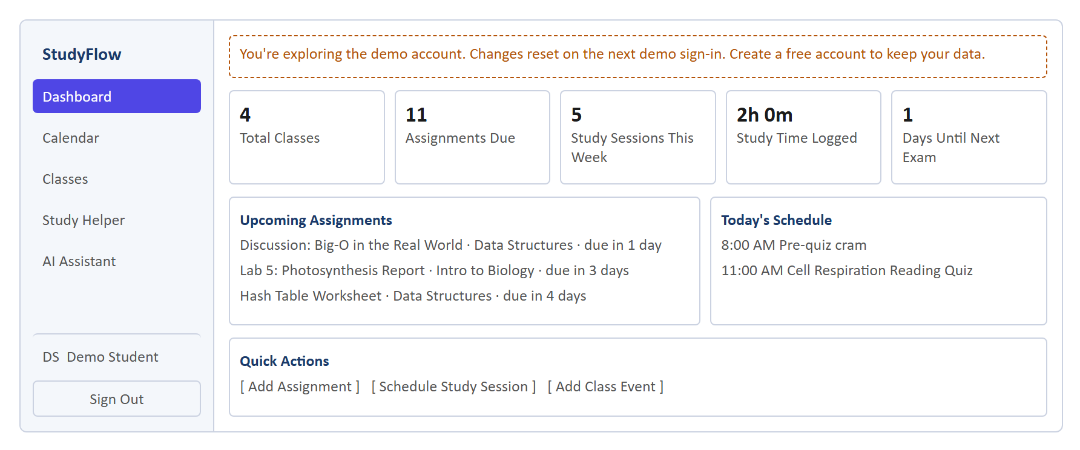
Figure 6.1. Dashboard wireframe (desktop) with demo data.

Screens
Login / Register /login · /register
- Email and password form
- “Try the demo” one-click button
- Register: name, email, password; inline errors for 400/409
Dashboard /dashboard
- Five statistic tiles
- Next 3 assignments, colored red ≤ 2 days, orange ≤ 5 days
- Today's schedule and study sessions
- Quick-add modals for assignment, study session, event
Calendar /calendar
- Month and week views with previous/next
- Events colored by class or type
- Day details panel; create, edit, delete modals
Classes /classes
- Class list with color, instructor, room, credits
- Selected class: progress bar, upcoming and completed assignments
- Filter by type, sort by due date or type; due-date badges
- Complete, grade, edit, delete
Study Helper /study
- Circular focus timer: start, pause, reset, duration
- Planned and completed sessions; insights (streak, weekly total)
- AI generator: class, mode, topic; rendered markdown and math
- Quiz cards: Show Answer, “I got it right / wrong”
AI Assistant /chat
- Conversation list with new and delete
- Message thread with live streaming reply
- Markdown, tables and KaTeX math rendering

Feedback conventions
- Loading: each section has a loading.tsx skeleton shown while data loads.
- Empty states: a centered icon, title and one line of guidance (for example “No events today”).
- Results: success and error toasts from a shared ToastProvider; API error messages are shown verbatim.
- Failures: route-level error.tsx and not-found.tsx pages.

6.2 – Internal REST API
All endpoints are same-origin under /api, accept and return JSON (except the chat stream), and identify the user from the NextAuth session cookie. Record IDs for PATCH and DELETE are passed as the ?id= query parameter. Errors return { "error": "message" }; the register endpoint returns { "success": false, "message" }.
Interface | Method and path | Request | Success response | Errors
IRegister | POST /api/auth/register | { name, email, password } | 201 { success: true } | 400, 409, 500
IAuth | GET|POST /api/auth/* | NextAuth: sign-in (credentials or demo), session, CSRF, sign-out | Session cookie / JSON | 401
IDashboard | GET /api/dashboard | — | { stats, upcomingAssignments, upcomingEvents, todaysSchedule, todaysStudySessions } | 401
IClasses | GET /api/classes | — | Class[] with assignments | 401
IClasses | POST /api/classes | { name, color?, instructor?, room?, credits? } | 201 Class | 400, 401
IClasses | PATCH /api/classes?id= | same as POST | Class | 400, 401, 404
IClasses | DELETE /api/classes?id= | — | { success: true } | 400, 401, 404
IAssignments | POST /api/assignments | { classId, title, assignmentType, dueDate, description?, grade? } | 201 Assignment | 400, 401, 404
IAssignments | PATCH /api/assignments?id= | any subset incl. isCompleted, grade | Assignment | 400, 401, 404
IAssignments | DELETE /api/assignments?id= | — | { success: true } | 400, 401, 404
ICalendar | GET /api/calendar?month=YYYY-MM | month optional | CalendarEvent[] | 400, 401
ICalendar | POST /api/calendar | { title, startDate, endDate, type, description?, color? } | 201 CalendarEvent | 400, 401
ICalendar | PATCH /api/calendar?id= | same as POST | CalendarEvent | 400, 401, 404
ICalendar | DELETE /api/calendar?id= | — | { success: true } | 400, 401, 404
IStudy | GET /api/study | — | StudySession[] with class | 401
IStudy | POST /api/study | { title, topic, scheduledDate, durationMinutes, studyType?, classId?, notes?, isCompleted? } | 201 StudySession | 400, 401, 404
IStudy | PATCH /api/study?id= | any subset | StudySession | 400, 401, 404
IStudy | DELETE /api/study?id= | — | { success: true } | 400, 401, 404
IGenerate | POST /api/study/generate | { className, studyType, topic, classId? } | { content } or, for Quiz Me, { questions: [{ question, answer, explanation }] } | 400, 401
IQuizAttempt | POST /api/study/quiz-attempt | { topic, question, isCorrect, classId? } | { success: true } | 400, 401
IChat | GET /api/chat[?id=] | id optional | Conversation list, or one conversation with messages | 401, 404
IChat | POST /api/chat | { message, conversationId? } | 200 text/plain stream; header X-Conversation-Id | 400, 401, 404
IChat | DELETE /api/chat?id= | — | { success: true } | 400, 401, 404

6.3 – External interfaces
Interface | Protocol | Used by | Contract
Ollama chat API (default) | HTTP POST {OLLAMA_URL}/api/chat | AIClient | Request { model, messages, stream, format?: "json", options: { num_ctx: 8192 } }. Non-streaming returns { message: { content } }; streaming returns NDJSON lines.
Groq API (optional) | HTTPS via groq-sdk | AIClient | chat.completions.create({ model, messages, stream?, response_format? }); needs GROQ_API_KEY. Default model openai/gpt-oss-120b.
NextAuth.js 4 | Library | AuthService, middleware | Two credentials providers (credentials, demo), JWT strategy, custom sign-in page /login.
Prisma Client 7 | Library, in-process | All controllers | Type-safe queries; PrismaBetterSqlite3 adapter opens DATABASE_URL.
Browser localStorage | Web Storage API | StudyPage | Key studyflow-focus-timer: { isRunning, secondsRemaining, sessionTitle, startTimestamp, sessionId, durationMinutes }.
Web Audio API | Browser API | StudyPage | Oscillator tone when a focus session ends.
Fetch Streams API | Browser API | ChatPage | response.body.getReader() reads the chat stream incrementally.

7.0 – Appendices

Appendix A – Technology stack
Layer | Technology | Version
Framework | Next.js (App Router), TypeScript | 16.3.5, 5.x
UI | React, Tailwind CSS, lucide-react icons | 19.2.8, 4.x, 1.46
Calendar and dates | react-calendar, date-fns | 6.0, 4.4
Rendering AI output | react-markdown, remark-gfm, remark-math, rehype-katex, rehype-raw, KaTeX | 10.1, 4.0, 6.0, 7.0, 7.0, 0.18
Authentication | NextAuth.js, bcryptjs | 4.24, 3.0
Database | Prisma ORM, better-sqlite3, SQLite | 7.10, 13.0
AI | Ollama with llama3 (default); groq-sdk | —, 1.6

Appendix B – Configuration
Variable | Required | Default | Purpose
DATABASE_URL | Yes | file:./dev.db | SQLite file location
NEXTAUTH_SECRET | Yes | — | Signs session JWTs
NEXTAUTH_URL | Yes | — | Public base URL
AI_PROVIDER | No | ollama | Set to groq for hosted models
OLLAMA_URL | No | http://localhost:11434 | Ollama server
OLLAMA_MODEL | No | llama3 | Local model name
GROQ_API_KEY | With Groq | — | Groq credential
GROQ_MODEL | No | openai/gpt-oss-120b | Groq model name

Appendix C – Requirements traceability
Req. | Subsystem | Interface | Tables | Design
R-1 | SS-2 | IRegister, IAuth | User | 4.1.2
R-2 | SS-3 | IClasses | Class | 4.1.3
R-3 | SS-3, SS-4 | IAssignments | Assignment, CalendarEvent | 4.1.4, A-1
R-4 | SS-4 | ICalendar | CalendarEvent | 4.1.5
R-5 | SS-5 | IStudy | StudySession, CalendarEvent | 4.1.6, A-5, A-6
R-6 | SS-6 | IGenerate, IQuizAttempt | QuizAttempt | 4.1.8, A-2
R-7 | SS-6 | IChat | ChatConversation, ChatMessage | 4.1.8, A-3, A-4
R-8 | SS-7 | IDashboard | all | 4.1.7
R-9 | SS-8 | IAuth (demo) | all | 4.1.9, A-7

Appendix D – Demo data set
Each demo sign-in creates 4 classes (Calculus II, Intro to Biology, Data Structures, World History), 16 assignments (5 completed with grades, 1 overdue, 1 due today, the rest upcoming over the next 20 days), 8 study sessions (3 completed), 4 personal events and 1 saved chat conversation about integration by parts.

Appendix E – Known limitations and future work
- “Days Until Next Exam” currently counts down to the next assignment-type calendar event of any assignment type. Filtering by Exam, Midterm and Final would match the label.
- Non-atomic paired writes. Creating an assignment or study session and its calendar event are two separate writes. Wrapping them in prisma.$transaction, as demo seeding already does, would prevent an orphaned record if the second write fails.
- Password policy. Registration checks that a password is present but not its length or strength.
- API rate limiting. AI endpoints have no per-user rate limit, which matters more with the paid Groq provider.
- Single-writer database. SQLite suits a single server instance. A multi-instance deployment would move to PostgreSQL by changing the Prisma datasource.
- Self-reported quiz results. Mastery tracking relies on the student's honest “right / wrong” click.
- Future features: LMS calendar import, reminder notifications, and shared study groups.

Appendix F – Glossary
Term | Meaning
App Router | Next.js routing where each folder under src/app is a URL and route.ts files are API handlers.
bcrypt | Slow, salted password-hashing function.
Cascade | Database rule that deletes child rows when the parent row is deleted.
JWT | JSON Web Token: a signed token that carries the user's id in the session cookie.
KaTeX | Library that renders LaTeX math in the browser.
LLM | Large language model, the AI that generates study material and chat replies.
NDJSON | Newline-delimited JSON: one JSON object per line, used for streaming.
Ollama | Free tool that runs open LLMs locally and serves them over HTTP.
ORM | Object-relational mapper; Prisma turns TypeScript calls into SQL.
SHA-256 | Cryptographic hash used to fingerprint quiz questions.

Appendix G – Revision history
Version | Date | Change
1.0 | 2026-11-09 | Initial specification, written against commit 5f519a4.

